A Comparative Study of Machine Learning, Deep Learning, and Foundation Models for Short-Term Electricity Load Forecasting

Abstract — Short-term electricity load forecasting is a key task for smart-grid operation, industrial energy management, and predictive planning. This paper presents a reproducible comparative study of classical, machine-learning, deep-learning, and foundation-model approaches for hourly load forecasting. The benchmark includes SeasonalNaive, SARIMA, XGBoost, DLinear, PatchTST, iTransformer, Chronos-Bolt-Small, and TimesFM 2.5. The primary dataset is ECL with aggregate electricity load as the target; ETTh1/HUFL is used as a secondary industrial benchmark. Experiments cover 24-, 96-, and 168-hour horizons with a 336-hour context window. Results show that XGBoost and zero-shot foundation models form the leading group on ECL, while DLinear and Chronos-Bolt dominate different horizons on ETTh1/HUFL. The study also evaluates latency and statistical significance, showing that foundation models are practical cold-start tools but do not universally replace strong supervised and classical baselines.
Keywords — short-term load forecasting, smart grid, time series, SARIMA, XGBoost, deep learning, foundation models, Chronos, TimesFM

Introduction
Short-term electricity load forecasting (STLF) supports dispatch planning, balancing, tariff-aware operation, maintenance planning, and anomaly-aware industrial energy management. Forecasting errors directly affect operational cost, reserve scheduling, and the reliability of downstream decision-support systems.
Modern energy systems generate large volumes of hourly and sub-hourly measurements. This makes it possible to train data-driven forecasting models, but it also creates a methodological problem: increasingly complex neural and foundation models must be compared against strong, transparent, and inexpensive baselines.
This paper presents a reproducible benchmark that compares classical statistical models, machine-learning methods, deep-learning architectures, and time-series foundation models under the same chronological evaluation protocol.

Related Work
Classical ARIMA-family models remain widely used in industrial forecasting because they are interpretable, computationally inexpensive, and well understood. Seasonal naive models form a necessary reference for load forecasting studies with strong daily or weekly seasonality.
Gradient-boosted decision trees are a strong machine-learning baseline for energy forecasting. Deep-learning models, including linear neural baselines and transformer-based architectures, are attractive for long-horizon forecasting but often require careful tuning and sufficient data.
Recent time-series foundation models, including Chronos and TimesFM, introduce forecasting without task-specific training. This is useful for cold-start settings, but public benchmark contamination must be acknowledged.

Materials and Methods
The benchmark is formulated as a univariate rolling-origin forecasting task. Given a context window of L=336 hourly observations, each model produces a multi-step point forecast for the next H values, where H ∈ {24, 96, 168}. All trained models minimize the mean squared error between the prediction and the observed target on the training split, and all metrics are reported on the held-out test split in the original target scale after inverse standardization.
$$\hat{y_{t+1:t+H}}=f\left(x_{t-L+1:t}\right), L=336, H∈\{24,96,168\}$$
The primary dataset is ECL (Electricity Consuming Load), aggregated across 321 clients at hourly resolution; the target is the aggregate load. The secondary dataset is ETTh1, where HUFL is used as the load target; the OT variable is oil temperature and is intentionally not interpreted as electricity load. ECL is split chronologically into 70% training, 10% validation, and 20% test. ETTh1 follows the standard 12 / 4 / 4 month chronological split. Standardization is fit only on the training split to avoid leakage, and predictions are inverse-transformed before metric computation.
Two classical baselines are included. SeasonalNaive repeats the most recent daily seasonal pattern. SARIMA performs an AICc-based grid search on the training split over (p, d, q) ∈ {(1,1,1), (2,1,1), (1,1,2), (2,1,2)} with seasonal orders (P, D, Q)₂₄ ∈ {(1,1,1), (2,1,1), (1,1,2)}; the lowest-AICc configuration is then reused on every test window via state filtering on the new context, yielding a fast and well-defined classical reference rather than an expensive per-origin AutoARIMA search.
$${\text{Φ}}_{\text{P}}\left(B^{s}\right) ϕ_{p}\left(B\right) {\left(1-B\right)}^{d}{\left(1-B^{s}\right)}^{D} y_{t}={\text{Θ}}_{\text{Q}}\left(B^{s}\right) θ_{q}\left(B\right) ε_{t}, s=24$$
XGBoost is trained as a direct multi-output regressor with one estimator per forecast step. Features comprise lag-1, lag-24, lag-168 values of the target; rolling means over 24 and 168 hours; and cyclic calendar encodings for hour-of-day, day-of-week, and month. DLinear, PatchTST, and iTransformer are trained through NeuralForecast in the same target-only setting, with a short validation-only learning-rate sweep over {1e-3, 5e-4} and early stopping by validation MAE. Although the train, validation, and test segments are concatenated to construct rolling windows, each window is predicted using only past observations, so no future information leaks into training.
Two time-series foundation models are evaluated in zero-shot mode without task-specific training: Chronos-Bolt-Small (47.7 M parameters) and TimesFM 2.5 (≈200 M parameters). Both are conditioned on the same L=336 context as the trained models to keep the comparison fair. We deliberately do not claim guaranteed dataset-unseen generalization: ECL and ETT are public benchmarks and may overlap with pretraining corpora used during foundation-model development.
Accuracy is measured with mean absolute error (MAE), root mean squared error (RMSE), symmetric mean absolute percentage error (sMAPE), and weighted mean absolute percentage error (wMAPE). MSE is omitted from the tables because it is redundant with RMSE. Efficiency is reported as training time, single-window inference latency at batch size 1 (averaged over a warm-up plus 20 repeats), trainable parameter count, and peak GPU memory.
$$\text{MAE}=\frac{1}{N}\sum_{i=1}^{N\backslash }{lvert}y_{i}-\hat{y_{i}\backslash }rvert$$
$$\text{RMSE}=\sqrt{\frac{1}{N}\sum_{i=1}^{N}{{\left(y_{i}-\hat{y_{i}}\right)}^{2}}}$$
$$\text{sMAPE}=\frac{200}{N}\sum_{i=1}^{N}{\frac{\backslash lverty_{i}-\hat{y_{i}\backslash }rvert}{\backslash lverty_{i}\backslash rvert+\backslash lvert\hat{y_{i}\backslash }rvert}}$$
$$\text{wMAPE}=100⋅\frac{\sum_{i=1}^{N\backslash }{lvert}y_{i}-\hat{y_{i}\backslash }rvert}{\sum_{i=1}^{N\backslash }{lvert}y_{i}\backslash rvert}$$
Stochastically initialized models (XGBoost, DLinear, PatchTST, iTransformer) are evaluated across five seeds {42, 43, 44, 45, 46} and reported as mean ± standard deviation. Deterministic models (SeasonalNaive, SARIMA, Chronos-Bolt, TimesFM) are evaluated once and have a standard deviation of zero by construction. Statistical comparisons use the Diebold-Mariano test on per-window absolute errors, with the squared-error loss differential, between the top two models by MAE for each (dataset, horizon) pair at seed 42.

Results
Figure 1 summarizes the execution pipeline. The pipeline covers data validation, chronological splitting, leakage-safe preprocessing, model execution, metric calculation, statistical tests, and paper-ready artifact generation.
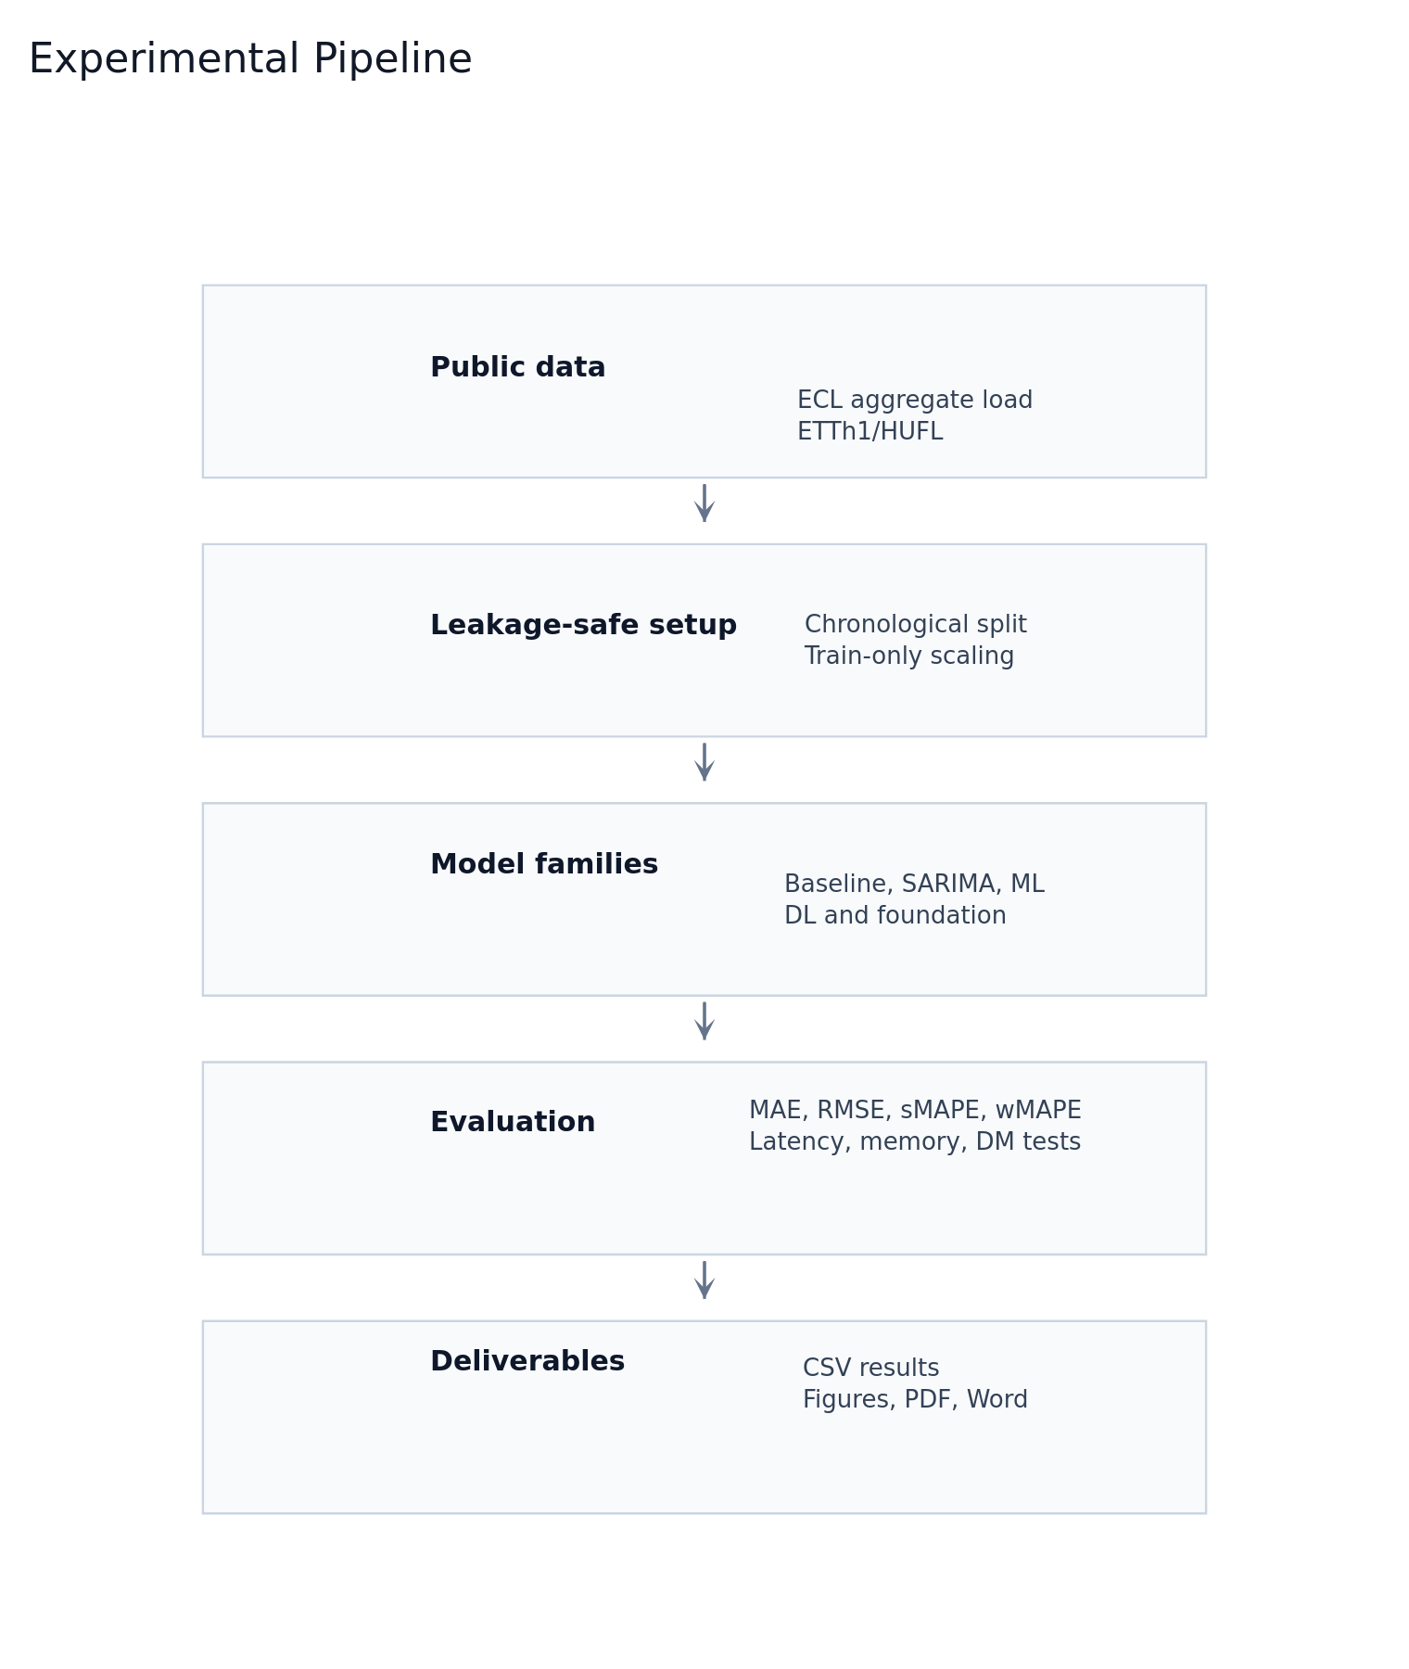
- Experimental pipeline used for the benchmark.
On ECL, the top group consists of TimesFM, Chronos-Bolt, and XGBoost. Their differences are small across all horizons. TimesFM is marginally best at H=24, while XGBoost is marginally best at H=96 and H=168. SARIMA remains close to this leading group.
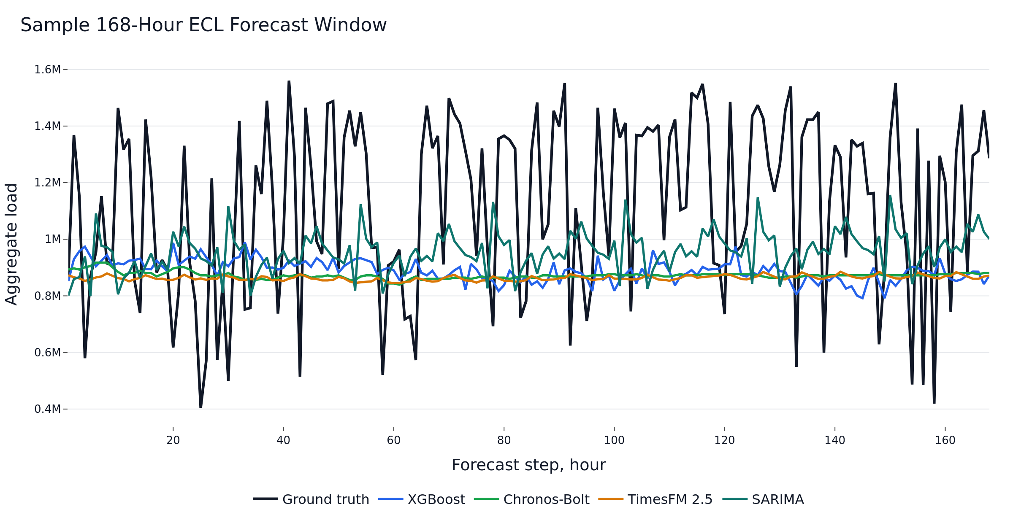
- Sample 168-hour ECL forecast window.
Dataset/H | Best model | Close competitors | Interpretation
ECL/H24 | TimesFM | Chronos-Bolt, XGBoost | Near tie
ECL/H96 | XGBoost | Chronos-Bolt, TimesFM | Tree model leads
ECL/H168 | XGBoost | Chronos-Bolt, TimesFM | Tree model robust
ETTh1/H24 | Chronos-Bolt | PatchTST, DLinear | Foundation model strongest
ETTh1/H96 | DLinear | Chronos-Bolt, PatchTST | Linear neural model wins
ETTh1/H168 | DLinear | Chronos-Bolt, TimesFM | DLinear strongest
- Summary of the main accuracy results.
On ETTh1/HUFL, the ranking changes. Chronos-Bolt is best at H=24, while DLinear is best at H=96 and H=168. This result supports the view that simple linear neural models remain highly competitive on some industrial time-series benchmarks.
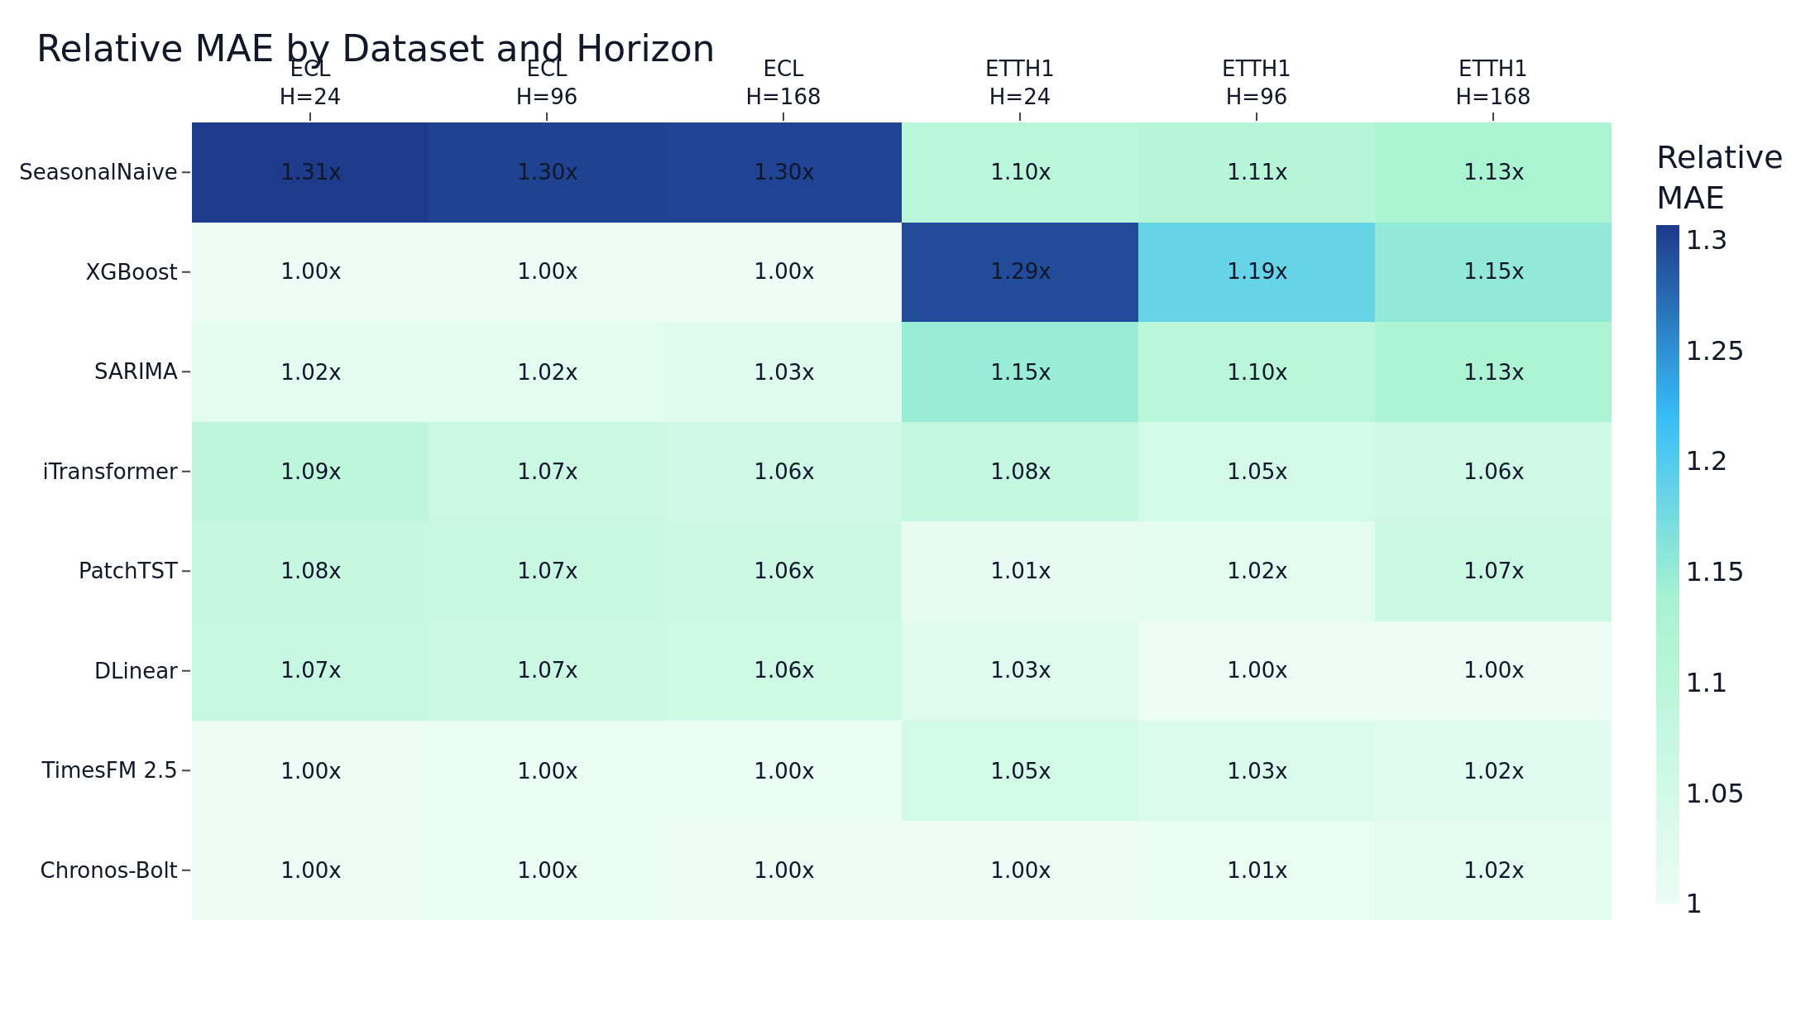
- Relative MAE by dataset and horizon.
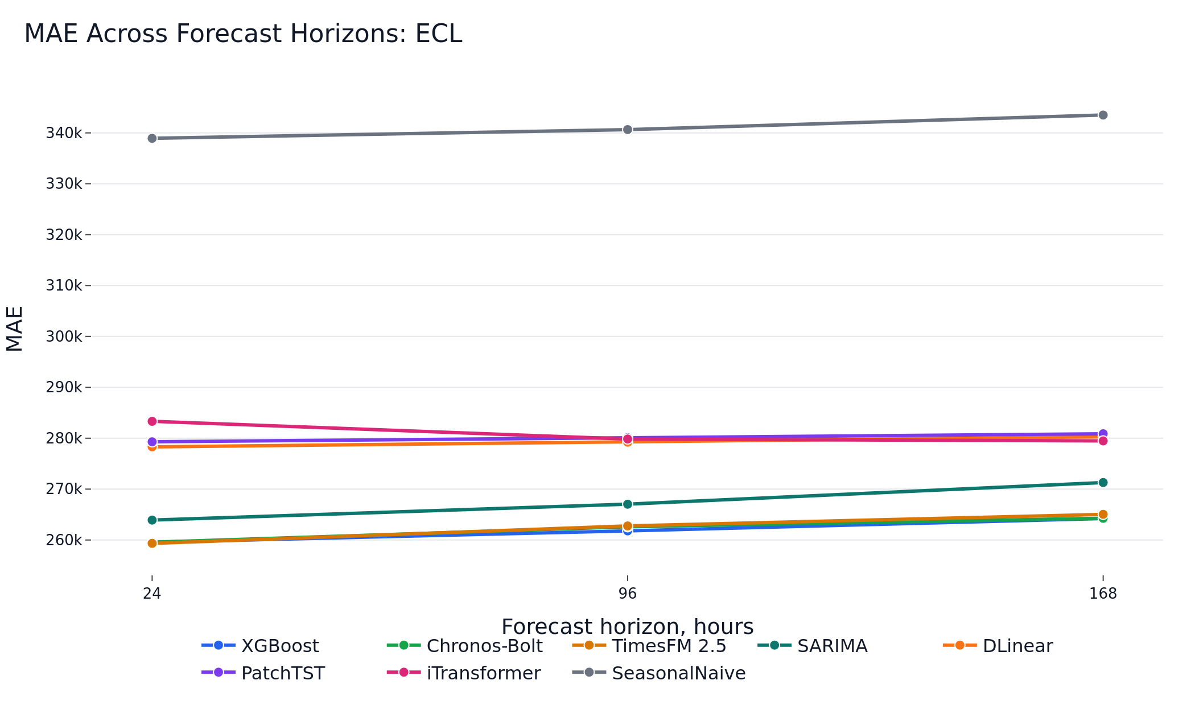
- MAE across forecast horizons on ECL.
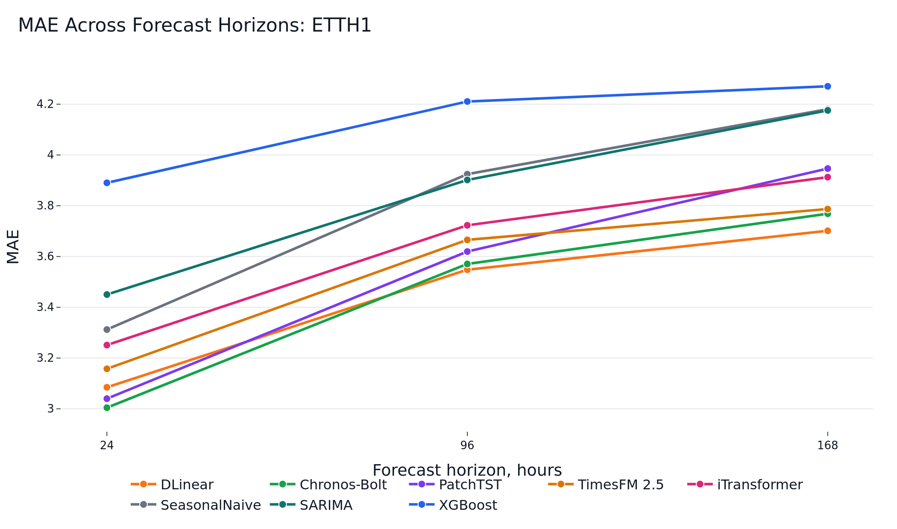
- MAE across forecast horizons on ETTh1/HUFL.
The Diebold-Mariano tests reject equal predictive accuracy for the top model pairs in all evaluated dataset-horizon combinations. However, on ECL the absolute differences among the top three methods are operationally small.
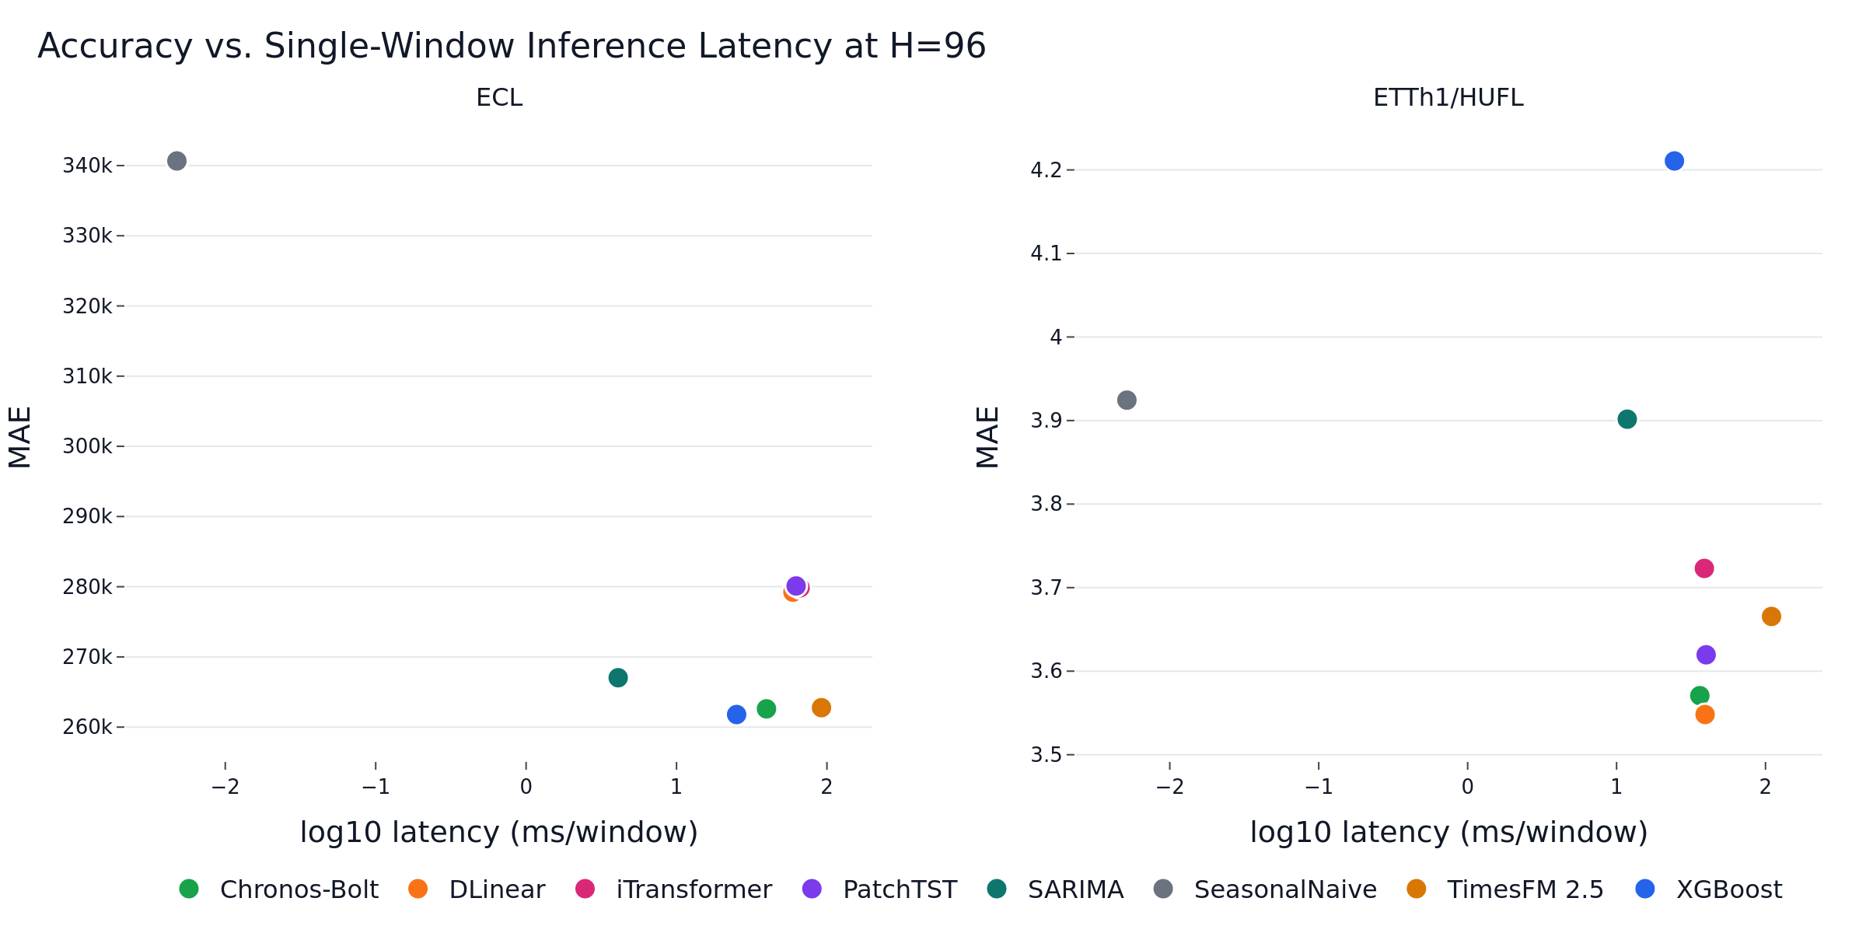
- Accuracy-latency view at H=96.
Family | Training cost | Inference profile | Practical role
SeasonalNaive/SARIMA | Low to moderate | Very low latency | Reference and fallback
XGBoost | Low | Low latency | Strong supervised baseline
DLinear/PatchTST/iTransformer | Moderate | GPU-friendly | Neural references
Chronos/TimesFM | No task-specific training | Model-dependent latency | Cold-start forecasting
- Operational interpretation of model families.
- ECL — accuracy across horizons (mean ± std over seeds where applicable).
Model | H | MAE | RMSE | sMAPE (%) | wMAPE (%)
TimesFM | 24 | 259345.28 | 307450.43 | 31.27 | 29.60
Chronos-Bolt | 24 | 259546.11 | 311466.37 | 31.32 | 29.63
XGBoost | 24 | 259549.38 ± 12.18 | 306563.19 ± 16.57 | 31.33 ± 0.00 | 29.63 ± 0.00
SARIMA | 24 | 263913.91 | 316245.26 | 31.73 | 30.12
DLinear | 24 | 278309.93 ± 70.17 | 327075.05 ± 108.63 | 34.58 ± 0.01 | 32.94 ± 0.01
PatchTST | 24 | 279295.35 ± 245.58 | 328419.63 ± 556.43 | 34.68 ± 0.03 | 33.05 ± 0.03
iTransformer | 24 | 283321.32 ± 249.36 | 335735.87 ± 571.58 | 35.11 ± 0.03 | 33.53 ± 0.03
SeasonalNaive | 24 | 338935.90 | 428088.82 | 39.98 | 38.69
XGBoost | 96 | 261792.58 ± 8.37 | 308906.88 ± 22.41 | 31.63 ± 0.00 | 29.94 ± 0.00
Chronos-Bolt | 96 | 262601.94 | 314012.89 | 31.68 | 30.03
TimesFM | 96 | 262766.32 | 311382.39 | 31.65 | 30.05
SARIMA | 96 | 267033.48 | 320436.95 | 32.07 | 30.54
DLinear | 96 | 279227.54 ± 46.94 | 327146.57 ± 48.36 | 34.69 ± 0.01 | 33.07 ± 0.01
iTransformer | 96 | 279842.21 ± 132.70 | 327663.71 ± 184.17 | 34.75 ± 0.01 | 33.14 ± 0.02
PatchTST | 96 | 280109.77 ± 84.36 | 328333.77 ± 229.61 | 34.77 ± 0.02 | 33.17 ± 0.01
SeasonalNaive | 96 | 340658.82 | 428618.32 | 40.13 | 38.96
XGBoost | 168 | 264220.96 ± 22.15 | 311145.57 ± 37.64 | 31.96 ± 0.00 | 30.30 ± 0.00
Chronos-Bolt | 168 | 264268.27 | 315996.95 | 31.91 | 30.30
TimesFM | 168 | 265044.60 | 313676.28 | 31.95 | 30.39
SARIMA | 168 | 271294.60 | 325857.78 | 32.54 | 31.11
iTransformer | 168 | 279476.02 ± 92.85 | 326253.85 ± 237.73 | 34.75 ± 0.01 | 33.15 ± 0.01
DLinear | 168 | 280272.56 ± 42.27 | 328134.31 ± 34.74 | 34.84 ± 0.01 | 33.25 ± 0.01
PatchTST | 168 | 280876.20 ± 97.69 | 328943.70 ± 235.33 | 34.88 ± 0.01 | 33.32 ± 0.01
SeasonalNaive | 168 | 343510.17 | 431537.72 | 40.48 | 39.39
- ETTh1/HUFL — accuracy across horizons (mean ± std over seeds where applicable).
Model | H | MAE | RMSE | sMAPE (%) | wMAPE (%)
Chronos-Bolt | 24 | 3.00 | 4.78 | 44.88 | 29.73
PatchTST | 24 | 3.04 ± 0.01 | 4.56 ± 0.01 | 47.47 ± 0.16 | 30.09 ± 0.10
DLinear | 24 | 3.08 ± 0.00 | 4.63 ± 0.00 | 47.95 ± 0.09 | 30.53 ± 0.04
TimesFM | 24 | 3.16 | 4.88 | 48.33 | 31.25
iTransformer | 24 | 3.25 ± 0.01 | 4.77 ± 0.04 | 49.29 ± 0.08 | 32.17 ± 0.13
SeasonalNaive | 24 | 3.31 | 5.44 | 46.07 | 32.78
SARIMA | 24 | 3.45 | 4.92 | 52.92 | 34.15
XGBoost | 24 | 3.89 ± 0.01 | 5.40 ± 0.01 | 57.47 ± 0.07 | 38.50 ± 0.06
DLinear | 96 | 3.55 ± 0.00 | 5.26 ± 0.01 | 54.11 ± 0.07 | 35.08 ± 0.02
Chronos-Bolt | 96 | 3.57 | 5.61 | 51.08 | 35.30
PatchTST | 96 | 3.62 ± 0.03 | 5.27 ± 0.02 | 54.87 ± 0.32 | 35.79 ± 0.25
TimesFM | 96 | 3.67 | 5.61 | 54.27 | 36.24
iTransformer | 96 | 3.72 ± 0.01 | 5.43 ± 0.02 | 55.56 ± 0.22 | 36.81 ± 0.11
SARIMA | 96 | 3.90 | 5.57 | 57.66 | 38.58
SeasonalNaive | 96 | 3.92 | 6.41 | 51.70 | 38.80
XGBoost | 96 | 4.21 ± 0.00 | 5.86 ± 0.01 | 61.21 ± 0.03 | 41.63 ± 0.05
DLinear | 168 | 3.70 ± 0.00 | 5.43 ± 0.01 | 56.49 ± 0.07 | 36.54 ± 0.02
Chronos-Bolt | 168 | 3.77 | 5.85 | 53.36 | 37.20
TimesFM | 168 | 3.79 | 5.75 | 55.77 | 37.38
iTransformer | 168 | 3.91 ± 0.02 | 5.62 ± 0.03 | 57.87 ± 0.20 | 38.62 ± 0.21
PatchTST | 168 | 3.95 ± 0.07 | 5.62 ± 0.07 | 58.51 ± 0.66 | 38.96 ± 0.66
SARIMA | 168 | 4.18 | 5.87 | 60.30 | 41.22
SeasonalNaive | 168 | 4.18 | 6.70 | 54.20 | 41.26
XGBoost | 168 | 4.27 ± 0.00 | 5.98 ± 0.01 | 61.54 ± 0.04 | 42.15 ± 0.05
- Computational efficiency (single-window inference at batch size 1).
Model | Data/H | Train s | Infer ms | Params | GPU MB
Chronos-Bolt | ECL/H24 | 0.00 | 15.62 | 47 718 016 | 123.3
DLinear | ECL/H24 | 11.80 | 55.86 | 16 176 | 26.3
iTransformer | ECL/H24 | 23.72 | 55.34 | 311 448 | 164.9
PatchTST | ECL/H24 | 43.08 | 55.71 | 168 280 | 608.6
SARIMA | ECL/H24 | 109.77 | 2.99 | 0 | 0.0
SeasonalNaive | ECL/H24 | 0.00 | 0.00 | 0 | 0.0
TimesFM | ECL/H24 | 0.00 | 102.23 | 200 000 000 | 895.6
XGBoost | ECL/H24 | 2.89 | 7.50 | 57 388 | 0.0
Chronos-Bolt | ECL/H96 | 0.00 | 39.64 | 47 718 016 | 345.8
DLinear | ECL/H96 | 18.84 | 59.40 | 64 704 | 29.8
iTransformer | ECL/H96 | 31.38 | 66.29 | 320 736 | 165.0
PatchTST | ECL/H96 | 49.98 | 62.40 | 361 888 | 612.4
SARIMA | ECL/H96 | 109.64 | 4.09 | 0 | 0.0
SeasonalNaive | ECL/H96 | 0.00 | 0.00 | 0 | 0.0
TimesFM | ECL/H96 | 0.00 | 91.99 | 200 000 000 | 895.6
XGBoost | ECL/H96 | 10.48 | 25.09 | 229 423 | 0.0
Chronos-Bolt | ECL/H168 | 0.00 | 45.30 | 47 718 016 | 381.4
DLinear | ECL/H168 | 26.00 | 64.16 | 113 232 | 32.7
iTransformer | ECL/H168 | 38.54 | 69.72 | 330 024 | 165.2
PatchTST | ECL/H168 | 56.94 | 75.29 | 555 496 | 617.3
SARIMA | ECL/H168 | 108.43 | 5.52 | 0 | 0.0
SeasonalNaive | ECL/H168 | 0.00 | 0.01 | 0 | 0.0
TimesFM | ECL/H168 | 0.00 | 200.35 | 200 000 000 | 896.4
XGBoost | ECL/H168 | 18.18 | 42.71 | 401 454 | 0.0
Chronos-Bolt | ETTH1/H24 | 0.00 | 13.48 | 47 718 016 | 123.3
DLinear | ETTH1/H24 | 10.70 | 39.98 | 16 176 | 26.2
iTransformer | ETTH1/H24 | 20.17 | 39.15 | 311 448 | 164.8
PatchTST | ETTH1/H24 | 39.82 | 39.10 | 168 280 | 608.3
SARIMA | ETTH1/H24 | 110.82 | 9.30 | 0 | 0.0
SeasonalNaive | ETTH1/H24 | 0.00 | 0.00 | 0 | 0.0
TimesFM | ETTH1/H24 | 0.00 | 98.19 | 200 000 000 | 895.6
XGBoost | ETTH1/H24 | 2.34 | 6.14 | 57 417 | 0.0
Chronos-Bolt | ETTH1/H96 | 0.00 | 36.24 | 47 718 016 | 345.8
DLinear | ETTH1/H96 | 9.90 | 39.29 | 64 704 | 29.8
iTransformer | ETTH1/H96 | 20.61 | 38.86 | 320 736 | 165.0
PatchTST | ETTH1/H96 | 38.60 | 39.95 | 361 888 | 612.6
SARIMA | ETTH1/H96 | 110.80 | 11.80 | 0 | 0.0
SeasonalNaive | ETTH1/H96 | 0.00 | 0.01 | 0 | 0.0
TimesFM | ETTH1/H96 | 0.00 | 109.76 | 200 000 000 | 895.6
XGBoost | ETTH1/H96 | 8.64 | 24.47 | 229 758 | 0.0
Chronos-Bolt | ETTH1/H168 | 0.00 | 64.73 | 47 718 016 | 381.4
DLinear | ETTH1/H168 | 10.09 | 40.71 | 113 232 | 32.6
iTransformer | ETTH1/H168 | 21.13 | 44.38 | 330 024 | 165.1
PatchTST | ETTH1/H168 | 39.07 | 42.39 | 555 496 | 617.0
SARIMA | ETTH1/H168 | 110.49 | 14.46 | 0 | 0.0
SeasonalNaive | ETTH1/H168 | 0.00 | 0.01 | 0 | 0.0
TimesFM | ETTH1/H168 | 0.00 | 208.51 | 200 000 000 | 896.4
XGBoost | ETTH1/H168 | 14.78 | 42.69 | 401 899 | 0.0
- Diebold-Mariano tests for the top two models by MAE at seed 42.
Data/H | Comparison | Statistic | p-value | Sig.
ECL/H24 | TimesFM vs XGBoost | 13.45 | <0.001 | yes
ECL/H96 | XGBoost vs Chronos-Bolt | -38.15 | <0.001 | yes
ECL/H168 | XGBoost vs Chronos-Bolt | -2.88 | 0.004 | yes
ETTH1/H24 | Chronos-Bolt vs PatchTST | -3.39 | <0.001 | yes
ETTH1/H96 | DLinear vs Chronos-Bolt | -2.48 | 0.013 | yes
ETTH1/H168 | DLinear vs Chronos-Bolt | -8.81 | <0.001 | yes

Discussion
The main finding is that no model family dominates across datasets and horizons. On aggregate ECL load, engineered lag features with XGBoost remain a strong and inexpensive supervised solution. SARIMA provides a competitive classical reference.
Foundation models are attractive when task-specific training is undesirable, for example in cold-start industrial monitoring or rapid prototyping. Their advantage is practical rather than universal.
The trained transformer models should not be interpreted as generally ineffective. The study uses a compact target-only setup and a limited training budget.

Limitations
The first limitation is public-benchmark pretraining contamination. ECL and ETT are public datasets, and they may overlap with corpora used during foundation-model development.
The second limitation is the target-only design. Real industrial forecasting systems often include weather, calendar events, tariffs, production schedules, and operational constraints.
The third limitation is the restricted hyperparameter budget. The comparison is intentionally reproducible and computationally bounded.

Conclusion
This paper presented a reproducible benchmark of classical, machine-learning, deep-learning, and foundation-model approaches for short-term electricity load forecasting.
The practical conclusion is that strong simple baselines remain necessary. Foundation models are valuable cold-start tools and competitive zero-shot forecasters, but they should be evaluated alongside SARIMA, XGBoost, and compact neural baselines before deployment decisions are made.

References
- T. Hong and S. Fan, "Probabilistic electric load forecasting: A tutorial review," International Journal of Forecasting, vol. 32, no. 3, pp. 914-938, 2016, doi: 10.1016/j.ijforecast.2015.11.011.
- W. Kong, Z. Y. Dong, Y. Jia, D. J. Hill, Y. Xu, and Y. Zhang, "Short-term residential load forecasting based on LSTM recurrent neural network," IEEE Transactions on Smart Grid, vol. 10, no. 1, pp. 841-851, 2019, doi: 10.1109/TSG.2017.2753802.
- E. Mocanu, P. H. Nguyen, M. Gibescu, and W. L. Kling, "Deep learning for estimating building energy consumption," Sustainable Energy, Grids and Networks, vol. 6, pp. 91-99, 2016, doi: 10.1016/j.segan.2016.02.005.
- D. L. Marino, K. Amarasinghe, and M. Manic, "Building energy load forecasting using deep neural networks," in Proc. 42nd Annu. Conf. IEEE Industrial Electronics Society (IECON), 2016, pp. 7046-7051, doi: 10.1109/IECON.2016.7793413.
- G. E. P. Box, G. M. Jenkins, G. C. Reinsel, and G. M. Ljung, Time Series Analysis: Forecasting and Control, 5th ed. Hoboken, NJ, USA: Wiley, 2015.
- R. J. Hyndman and G. Athanasopoulos, Forecasting: Principles and Practice, 3rd ed. Melbourne, Australia: OTexts, 2021. [Online]. Available: https://otexts.com/fpp3/
- R. J. Hyndman and Y. Khandakar, "Automatic time series forecasting: The forecast package for R," Journal of Statistical Software, vol. 27, no. 3, pp. 1-22, 2008, doi: 10.18637/jss.v027.i03.
- F. X. Diebold and R. S. Mariano, "Comparing predictive accuracy," Journal of Business & Economic Statistics, vol. 13, no. 3, pp. 253-263, 1995, doi: 10.1080/07350015.1995.10524599.
- T. Chen and C. Guestrin, "XGBoost: A scalable tree boosting system," in Proc. 22nd ACM SIGKDD Int. Conf. Knowledge Discovery and Data Mining, 2016, pp. 785-794, doi: 10.1145/2939672.2939785.
- S. Hochreiter and J. Schmidhuber, "Long short-term memory," Neural Computation, vol. 9, no. 8, pp. 1735-1780, 1997, doi: 10.1162/neco.1997.9.8.1735.
- A. Vaswani, N. Shazeer, N. Parmar, J. Uszkoreit, L. Jones, A. N. Gomez, L. Kaiser, and I. Polosukhin, "Attention is all you need," in Advances in Neural Information Processing Systems (NeurIPS), 2017.
- H. Zhou, S. Zhang, J. Peng, S. Zhang, J. Li, H. Xiong, and W. Zhang, "Informer: Beyond efficient transformer for long sequence time-series forecasting," in Proc. AAAI Conf. Artificial Intelligence, 2021, doi: 10.1609/aaai.v35i12.17325.
- H. Wu, J. Xu, J. Wang, and M. Long, "Autoformer: Decomposition transformers with auto-correlation for long-term series forecasting," in Advances in Neural Information Processing Systems (NeurIPS), 2021.
- T. Zhou, Z. Ma, Q. Wen, X. Wang, L. Sun, and R. Jin, "FEDformer: Frequency enhanced decomposed transformer for long-term series forecasting," in Proc. Int. Conf. Machine Learning (ICML), 2022.
- A. Zeng, M. Chen, L. Zhang, and Q. Xu, "Are transformers effective for time series forecasting?" in Proc. AAAI Conf. Artificial Intelligence, 2023, doi: 10.1609/aaai.v37i9.26317.
- Y. Nie, N. H. Nguyen, P. Sinthong, and J. Kalagnanam, "A time series is worth 64 words: Long-term forecasting with transformers," in Proc. Int. Conf. Learning Representations (ICLR), 2023.
- H. Wu, T. Hu, Y. Liu, H. Zhou, J. Wang, and M. Long, "TimesNet: Temporal 2D-variation modeling for general time series analysis," in Proc. Int. Conf. Learning Representations (ICLR), 2023.
- Y. Liu, T. Hu, H. Zhang, H. Wu, S. Wang, L. Ma, and M. Long, "iTransformer: Inverted transformers are effective for time series forecasting," in Proc. Int. Conf. Learning Representations (ICLR), 2024.
- Q. Wen, T. Zhou, C. Zhang, W. Chen, Z. Ma, J. Yan, and L. Sun, "Transformers in time series: A survey," in Proc. Int. Joint Conf. Artificial Intelligence (IJCAI), 2023.
- A. Das, W. Kong, R. Sen, and Y. Zhou, "A decoder-only foundation model for time-series forecasting," in Proc. Int. Conf. Machine Learning (ICML), 2024.
- A. F. Ansari et al., "Chronos: Learning the language of time series," Transactions on Machine Learning Research, 2024.
- M. Goswami, K. Szafer, A. Choudhry, Y. Cai, S. Li, and A. Dubrawski, "MOMENT: A family of open time-series foundation models," in Proc. Int. Conf. Machine Learning (ICML), 2024.
- G. Woo, C. Liu, A. Kumar, C. Xiong, S. Savarese, and D. Sahoo, "Unified training of universal time series forecasting transformers," in Proc. Int. Conf. Machine Learning (ICML), 2024.
- K. Rasul et al., "Lag-Llama: Towards foundation models for probabilistic time series forecasting," 2024, arXiv:2310.08278.
- G. Lai, W.-C. Chang, Y. Yang, and H. Liu, "Modeling long- and short-term temporal patterns with deep neural networks," in Proc. 41st Int. ACM SIGIR Conf. Research & Development in Information Retrieval, 2018, pp. 95-104, doi: 10.1145/3209978.3210006.
- K. G. Olivares, C. Challu, F. Garza, M. Mergenthaler-Canseco, and A. Dubrawski, "NeuralForecast: User friendly state-of-the-art neural forecasting models," 2022. [Online]. Available: https://github.com/Nixtla/neuralforecast
- F. Garza, M. Mergenthaler-Canseco, K. G. Olivares, and C. Challu, "StatsForecast: Lightning fast forecasting with statistical and econometric models," 2022. [Online]. Available: https://github.com/Nixtla/statsforecast
- S. Seabold and J. Perktold, "statsmodels: Econometric and statistical modeling with Python," in Proc. 9th Python in Science Conf. (SciPy), 2010, pp. 92-96.

